The North Sea region after the Black Death:
recession, stagnation or golden age?
Research seminar with Bruce Campbell (Queen’s University Belfast), organized by the Antwerp Centre for Urban History.
Antwerp, Monday 19th of March 2018, 15:00-17:30
Venue? UAntwerpen, Meerminne, M003 (https://www.uantwerpen.be/images/uantwerpen/container1161/files/CST_17_NED.pdf

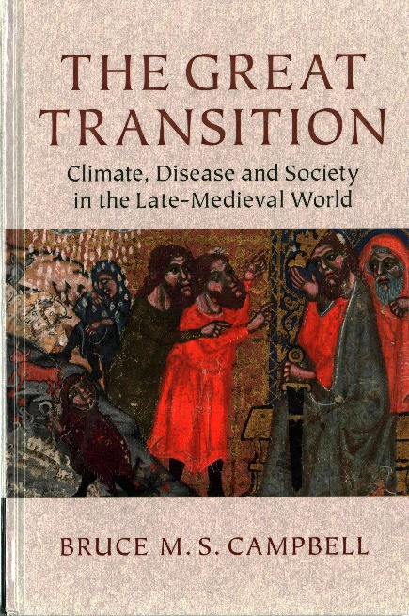
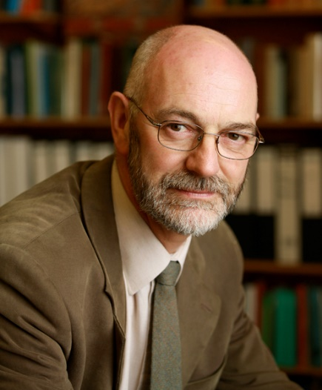
With The Great Transition. Climate, Disease and Society in the Late Medieval World (CUP, 2016), Bruce Campbell has rewritten the history of both the Black Death and the European economy in the later Middle Ages. After the Great Transition the economic history of the pre-industrial world can no longer be told without taking into account climate and ecology. The Great Transition also fundamentally challenges our view of post-Black Death Europe: once the tipping point of the 1340s had been passed, Europe gradually found itself in conditions which no longer resembled the world of growth and expansion of the 12th and 13th centuries. Instead repeated plague outbreaks, demographic contraction, bullion famine, economic depression and commercial isolation characterized Europe between c. 1390 and c. 1490. For historians of the ‘Burgundian’ Low Countries, this might be a rather ‘shocking’ perspective. While not dismissing the crisis of the Later Middle Ages all together, historians of the Low Countries often tend to focus on the persistent urban economic, political and cultural dynamics of this period. Did the urban Low Countries escape the ‘systemic changes’ of the Later Middle Ages? Or, were they rather the exception to the rule, an island of ‘prosperity amidst adversity’? Or do we have to reassert the scale and depth of economic contraction and declining employment in the Later Middle Ages, even in the core regions of the Low Countries?
In this afternoon seminar, Bruce Campbell presents recent estimates of English GDP per head, daily real wage rates of men and women and annual earnings. These invite us to rethink the transformation of labour after the Black Death, starting from debates on the so-called Golden Age of Labour, declining employment and a growing leisure preference. His presentation will be followed by two papers on the Low Countries.

- Monday 19th March 2018, 15:00-17:30 M003

15:00: Bruce M.S. Campbell (The Queen’s University of Belfast)
Unemployment, leisure and industriousness in late-medieval and renaissance Europe

15:50: Sam Geens and Tim Soens (UAntwerp):
A golden age of leisure? Employment rates in coastal Flanders between the 13th and 15th century.

16:15: Peter Stabel (UAntwerp):
Winners and losers. Urban labour and economic decline in the post-Black Death Low Countries

16:40: Discussion

17:15: Drinks

- Tuesday 20th March, 10:30-12:30, R008

On Tuesday, Bruce Campbell will give a second lecture on: The Black Death: an enduring enigma.
Venue: UAntwerpen, City Campus, R008

How to attend?
Attendance of both seminar and lecture is free, but please register in advance by e-mail: tim.soens@uantwerpen.be

