International Conference
The Ten Commandments in medieval and early modern culture
Ghent University, Belgium
April 10-11, 2014

Key note speakers: Robert J. Bast (University of Tennessee, Knoxville)
Lesley Smith (University of Oxford)

Call for Papers
The Department of Literature at Ghent University is pleased to announce that it will host an international conference on the Ten Commandments in medieval and early modern culture on April 10-11, 2014. We kindly invite paper proposals exploring this theme from any field of medieval and early modern studies. Selected papers will be published in a volume to be included in the peer-reviewed series Intersections. Interdisciplinary Studies in Early Modern Culture (Brill Publishers).
The rise to prominence of the Ten Commandments dates back to the 12th century. In that period exegetes such as Hugh of Saint Victor emphasized the importance of the Decalogue as a list of moral principles. A century later the Ten Commandments permeated scholastic learning as well as catechetical teaching. They became a useful instrument for the examination of conscience in preparation for the mandatory annual confession introduced by the Fourth Lateran Council (1215). By the second half of the 15th century, the Commandments were omnipresent in religious culture. Their diverse textual and visual manifestations were found in a variety of media, from manuscripts and printed books, to wall paintings and wooden panels. The prominence of the Decalogue continued amongst the Protestants, albeit with a different emphasis than in Catholic teaching.
The heterogeneity of the preserved Decalogue material inspires numerous research questions, many of which are vital and yet largely unexplored. It also poses methodological challenges to scholars who seek to explore and understand the role of the Ten Commandments within a broader context of medieval and early modern culture. Bearing this in mind, we would like to invite papers that elaborate on various aspects of textual – both Latin and vernacular – and visual manifestations of the Decalogue in the Middle Ages and the Early Modern period. It is particularly important that the proposed papers put emphasis on the broader cultural context in which the Decalogue functioned, as well as on the methodological and theoretical aspects of the discussed piece of research. Possible topics include, but are not limited to:
- The relationship (or lack of it) between scholastic and vernacular writings on the Ten Commandments. Recent research has shown that some vernacular writings on the Ten Commandments contain elaborate theological content. Which themes found their way from academic to vernacular theology? Were there independent developments within the vernacular writings on the Decalogue? In which milieus were the ‘learned’ vernacular treatises written and what was their audience?
- The Ten Commandments in various textual genres. The typological diversity of writings on the Decalogue is astonishing. These Old Testament tenets were explored in scholastic summae, catechetical mirrors and sermons, put into simple rhymes, combined with images and even interwoven into stage plays. How did different genres treat the Commandments? Was there any genre-specific emphasis on certain aspects of the exegesis of the Decalogue?
- The Ten Commandments in visual arts. The act of breaking or obeying the precepts was depicted in diverse media. Did the iconography and/or function of the Ten Commandments scenes change depending on the medium? Did the Reformation and Counter-Reformation affect the iconography of the Decalogue-scenes?
- The Decalogue in medieval and early modern popular culture. The Ten Commandments, like other tenets, penetrated popular (religious) culture. How did the abundantly preserved Decalogue rhymes, some of which could in fact be sung, and cheap prints containing a combination of text and image function? Who used them?
- The Ten Commandments in early modern theology. The Decalogue played a vital role in Protestant theology. Did the reformers postulate any major shifts in the interpretation of the Old Testament precepts? If so, did it cause any reaction by the catholic theologians?
Papers should be given in English and should be 20-25 minutes long. Please submit an abstract (max. 300 words) accompanied by a brief CV before October 1, 2013 by e-mail to Marta Bigus (marta.bigus@ugent.be). Successful applicants will be notified by November 1, 2013.
We look forward to receiving your abstracts, and to a productive meeting on April 10-11, 2014. We hope that you will support our efforts by notifying your colleagues and students about the conference. You are most welcome to contact the organisers for further details. For more information, please visit our website: www.tencommandments.ugent.be.
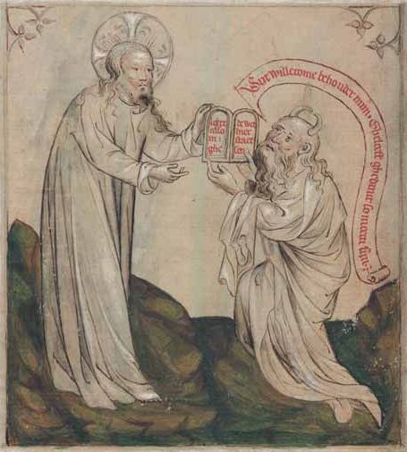
Organising committee:

Marta Bigus, MA (marta.bigus@ugent.be)
Prof. dr. Youri Desplenter (youri.desplenter@ugent.be)
Prof. dr. Jürgen Pieters (jurgen.pieters@ugent.be)
www.tencommandments.ugent.be

