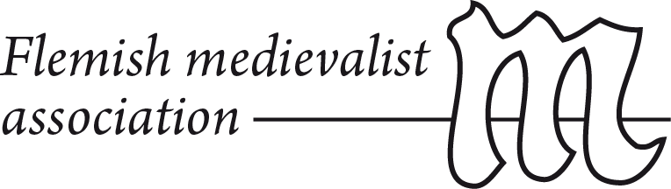
Pirenne-lecture, November 22th 2016, Ghent
Dr. Patrick Lantschner
The Other Crisis in the Age of the Crusades:
Political Volatility and City-States in the Later Medieval Mediterranean World

Wars between states were only one dimension of the crisis which the Mediterranean world experienced in the Age of the Crusades (c.1100-1500). This period saw another, often overlooked, crisis of political authority within many states across the Christian and Islamic spheres of the Mediterranean world. The crystallisation and subsequent transformation of city-states was reflective of the volatility and propensity to civil war and conflict which was inherent in many of the diverse political systems of the later medieval Mediterranean world. This lecture therefore returns to two themes that were central to Pirenne's work: the division between Christian and Islamic spheres, and the place of cities in medieval civilisation. Taking a comparative perspective on the most strongly urbanised regions of Italy, Syria and the Islamic West, this lecture investigates the conditions under which cities turned into important arenas of political confrontation and how they could sometimes also be among the greatest obstacles to the consolidation of states.

